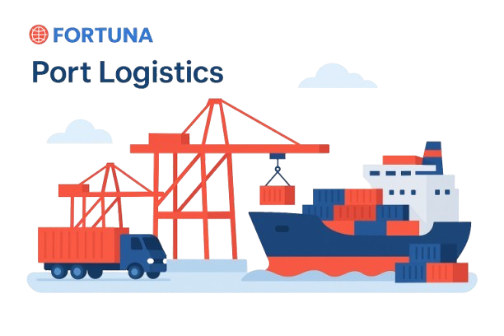

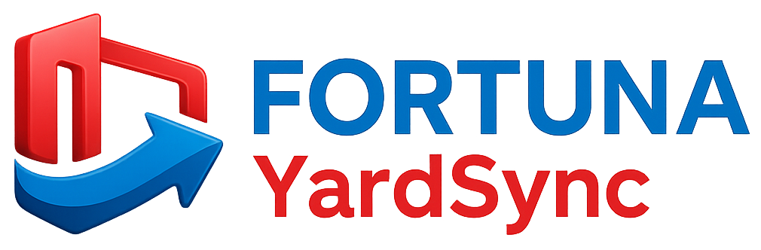

Website: www.fortunaglobalsupplychain.com
E-mail: info@fortunaglobalsupplychain.com

🏢 Company Overview

Fortuna Global Supply Chain Systems is a next-generation enterprise technology company revolutionizing the global logistics and supply chain landscape.
With a vision to create intelligent, transparent, and connected ecosystems, Fortuna blends innovation, data intelligence, and automation to help businesses achieve supply chain excellence.
Established with the belief that efficiency is the new currency, Fortuna empowers organizations to manage operations smarter — from demand planning to last-mile delivery — through real-time insights and seamless digital integration.
We are not just a technology provider; we are partners in transformation — driving global supply chain optimization with precision, performance, and predictive intelligence.

FORTUNA GLOBAL SUPPLY CHAIN SYSTEMS

“The Future of Enterprise Intelligence.”

Fortuna Yard Sync- Smart Yard & Dock Management System

Fortuna Yard Sync is a next-generation AI-driven Yard and Dock Management Platform designed to bring real-time visibility, control, and efficiency to inbound and outbound logistics operations.
It synchronizes vehicle entry, docking, loading, unloading, and dispatch activities within industrial yards, warehouses, and distribution centers — ensuring optimized turnaround times, reduced congestion, and seamless coordination between warehouse, transport, and gate operations.
“Fortuna Yard Sync transforms your yard into an intelligent, orchestrated ecosystem — where every truck, gate, and dock moves in perfect rhythm.”

Modern supply chains lose valuable time and efficiency at yards and loading docks, where manual coordination leads to delays, congestion, and visibility gaps.
Fortuna Yard Sync solves this through AI scheduling, IoT sensors, and cloud-based monitoring, offering real-time tracking, intelligent dock allocation, and predictive alerts to streamline every vehicle movement inside the yard.
The result:
- Reduced waiting time

- Improved asset utilization

- Faster gate-to-gate cycle

- End-to-end visibility

⚙️ 2. System Architecture
Fortuna Yard Sync operates within the Fortuna Intelligent Cloud Framework, comprising:
1️⃣ Cloud Infrastructure Layer – Secure SaaS environment (AWS / Azure).
2️⃣ IoT & Sensor Integration Layer – Real-time yard, gate, and vehicle data capture.
3️⃣ AI Intelligence Layer – Predictive scheduling, event optimization, and alerts.
4️⃣ Application Layer – Interactive dashboards for supervisors, guards, and logistics teams.

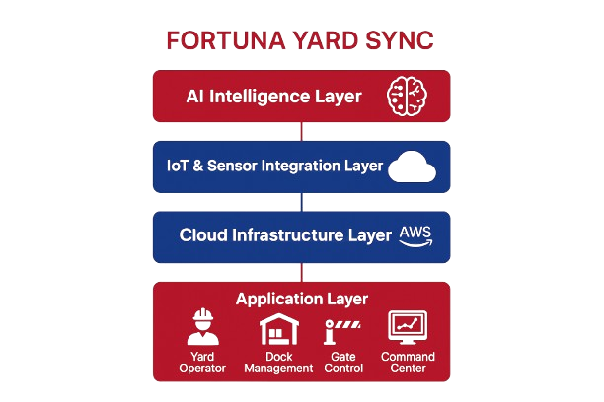

🚪 1: Gate Entry & Access Control

Product Modules, Sub-Modules & Operational Functionality

📚 Submodules:
- Vehicle Registration & Verification
- Driver ID & e-Pass Management
- Entry Scheduling & Time Slot Control
- Security Validation with QR/License Scan

⚙️ Operational Functionality:
- Automated gate check-in using QR or RFID scanning.
- Real-time validation of driver credentials and shipment details.
- Auto-allocation of gate entry based on scheduled time slot.
- Integration with Fortuna TMS for pre-approved trip authentication.
- Live dashboard for entry queue management and security supervision.

Product Modules, Sub-Modules & Operational Functionality

📚 Submodules:
- Historical Data Modelling – Learns from past sales, promotions, and seasonal behaviour.
- AI Forecast Generator – Produces short-term, mid-term, and long-term forecasts.
- External Signal Integration – Considers weather, events, and market indexes.
- Forecast Accuracy Tracker – Monitors prediction reliability using MAPE & RMSE.

⚙️ Operational Functionality:
- Automatically collects and cleans data from ERP/POS systems.
- Generates rolling forecasts updated daily or weekly.
- Uses deep learning algorithms to detect new demand trends.
- Provides scenario simulations (“what-if” analysis).

🏗️ 2: Yard Vehicle Tracking & Monitoring

📚 Submodules:
- Real-Time Yard Map View
- Vehicle Status Tracking (Arrived / Waiting / Loading / Dispatched)
- Geo-Fence & IoT Tag Integration
- Dock Queue Visualization

⚙️ Operational Functionality:
- Interactive yard layout showing vehicle location and movement.
- IoT sensors and geo-tags capture truck position within the yard.
- Color-coded status indicators for faster identification.
- Auto-alerts for overstayed or idle vehicles.
- Historical playback of yard activity for audits.

🏗️ 3: Dock & Slot Management

📚 Submodules:
- Dock Scheduling Engine
- Dynamic Slot Assignment
- Load/Unload Task Management
- Equipment & Crew Coordination

⚙️ Operational Functionality:
- AI engine optimizes dock utilization based on load, weight, and type.
- Real-time dock assignment for inbound and outbound trucks.
- Automated alerts for dock availability and delays.
- Integration with Fortuna SIMS for material availability and dispatch readiness.
- Digital job cards for crew, equipment, and task tracking.

🏗️ 4: Appointment & Schedule Management

📚 Submodules:
- Appointment Booking Portal (Supplier/Transporter)
- AI Slot Recommendation Engine
- Reschedule & Approval Workflow
- SLA Monitoring Dashboard

⚙️ Operational Functionality:
- Web portal for suppliers and transporters to book delivery/pickup slots.
- AI recommends optimal slots based on congestion patterns.
- Automatic approval and scheduling via cloud integration.
- Monitors on-time arrival and departure performance against SLA benchmarks.

📦 5: Load, Unload & Turnaround Management

📚 Submodules:
- Loading/Unloading Operation Tracker
- Turnaround Time Analytics (Gate-In → Gate-Out)
- Dock Utilization Metrics
- Delay Cause Analysis

⚙️ Operational Functionality:
- Tracks every minute of loading/unloading cycle via mobile app or IoT feed.
- AI calculates turnaround time for each trip.
- Visual KPIs for dock and operator efficiency.
- Auto-escalation for delayed operations.

💻 6: Control Tower & Command Center

📚 Submodules:
- Unified Yard Dashboard
- Event Alerts & Notifications
- Exception Handling & Escalation
- Live Video / IoT Sensor Feed Integration

⚙️ Operational Functionality:
- Centralized monitoring for multiple yards and facilities.
- Real-time alerts for safety breaches or idle vehicles.
- Integration with CCTV / IoT for automated anomaly detection.
- Command-based workflows for security and operations staff.

📈 7: Analytics & Reporting

📚 Submodules:
- KPI Performance Dashboards
- Yard Utilization Heat Maps
- Delay & Exception Reports
- Predictive Efficiency Analytics

⚙️ Operational Functionality:
- Visual analytics for throughput dwell time, and utilization.
- Predictive performance tracking for yards, docks, and gates.
- Exportable reports (PDF, Excel, API feed) for management.
- Comparative analysis between multiple sites or regions.

📈 Functional Workflows

Inbound Flow
Trip Creation (via TMS)
Gate Check-In
Dock Allocation
Unload Operation
Gate-Out
Performance Record Update

B. Outbound Flow
Dock Allocation
Loading & Weight
Gate Clearance
Dispatch
Delivery Confirmation
SLA Evaluation

C. Scheduling Workflow
Appointment Booking
AI Slot Suggestion
Dock Scheduling
Reschedule or Escalation
Slot Confirmation

Fortuna Yard Sync Advantages
Feature | Business Value
AI Powered Scheduling | Reduces congestion & idle time
IoT Vehicle Tracking | Real-time visibility & yard control
Cloud SaaS Platform | Accessible, scalable & secure
Integrated Dock & Gate Ops | Smooth flow between TMS & WMS
Centralized Control Tower | Unified view for multi-site operations
Predictive Analytics | Proactive performance management

Automotive & Industrial Manufacturing

🏭 Industries Served


FGSCM - supports the automotive sector with advanced logistics planning, vendor coordination, and predictive maintenance scheduling. From global parts movement to plant-level production support, our systems reduce lead times and enhance supply chain agility

Ports & Logistics
•


Fortuna supports the automotive sector with advanced logistics planning, vendor coordination, and predictive maintenance scheduling. From global parts movement to plant-level production support, our systems reduce lead times and enhance supply chain agility

Food & Beverage Distribution
•

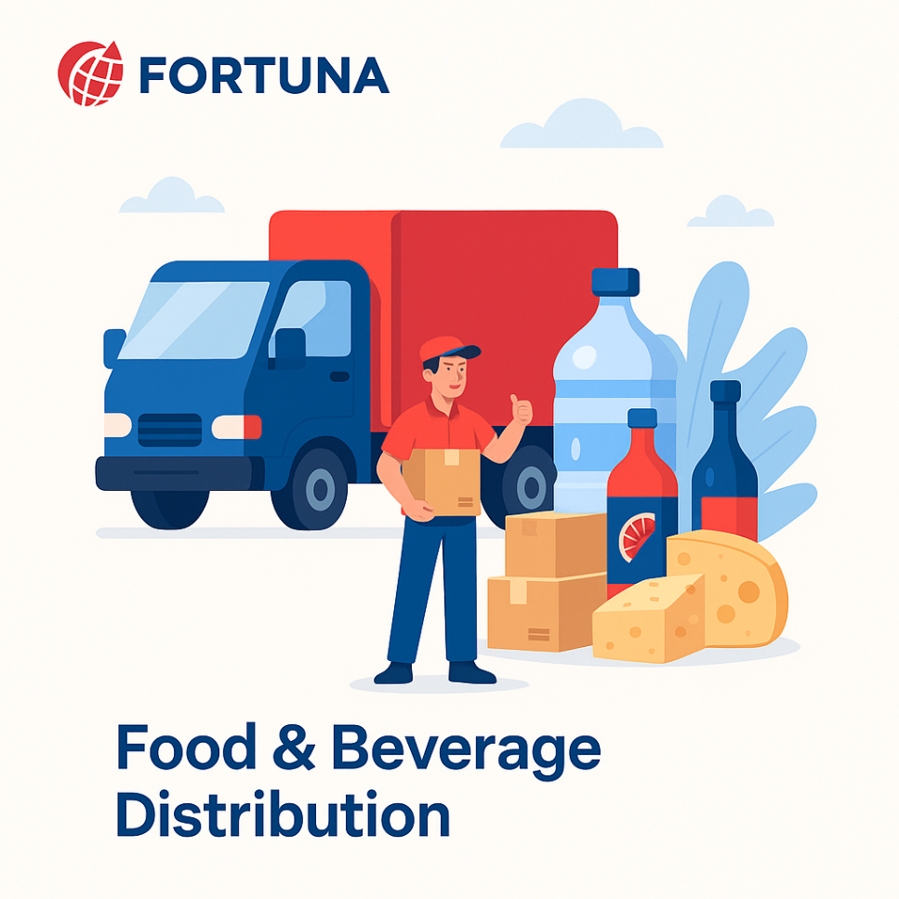
Freshness and safety are at the heart of Food & Beverage -supply chains. We enable end-to-end visibility with IoT-driven tracking, automated quality checks, and predictive demand planning—ensuring traceability from farm to fork.

Fashion & Retail Industry
•


With High seasonal demand & agile supply chain Planning, Fortuna will empowers retailers with faster replenishment & reduces stock outs

Pharma & Healthcare
•


Medical safety and regulatory compliance are non-negotiable. We provide automated solutions for cold chain logistics, product traceability, and compliance monitoring—ensuring life-saving medicines and healthcare products reach destinations safely and efficiently.

E-Commerce & Distributional Channels
•


In a fast-moving E-Com world, speed and efficiency are critical. Our platforms enable automated order management, demand forecasting, and last-mile delivery optimization—ensuring customers receive the right products, at the right time, every time.

🏛️ Corporate Identity

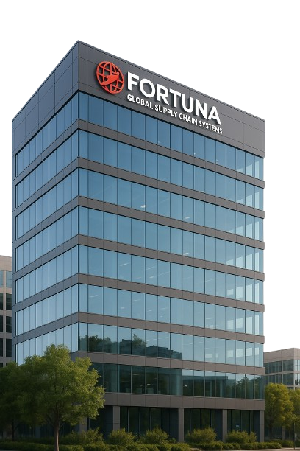
Headquarters: Visakhapatnam, Andhra Pradesh, India
Website: www.fortunaglobalsupplychain.com
Email: info@fortunaglobalsupplychain.com

